**AWS SPRING BOOT DEPLOY**

**Prerequisites**

1. AWS ACCOUNT
2. GENERATED JAR FILE FROM SPRING BOOT PROJECT
3. MySQL Database
4. Basic Understanding of AWS Services
5. > Change the **server.port=5000** because ElasticBeanstalck will recognize on port 5000.

* AS I mentioned database configuration **${RDS_HOSTNAME}** like that follow and change **application.Properties** file (ex: URL, username, password,) because we will change it in ASW Environment Variables.
* And then create JAR file **\* I will mention in last of this DOC how to create JAR file in STS and Upload it**.

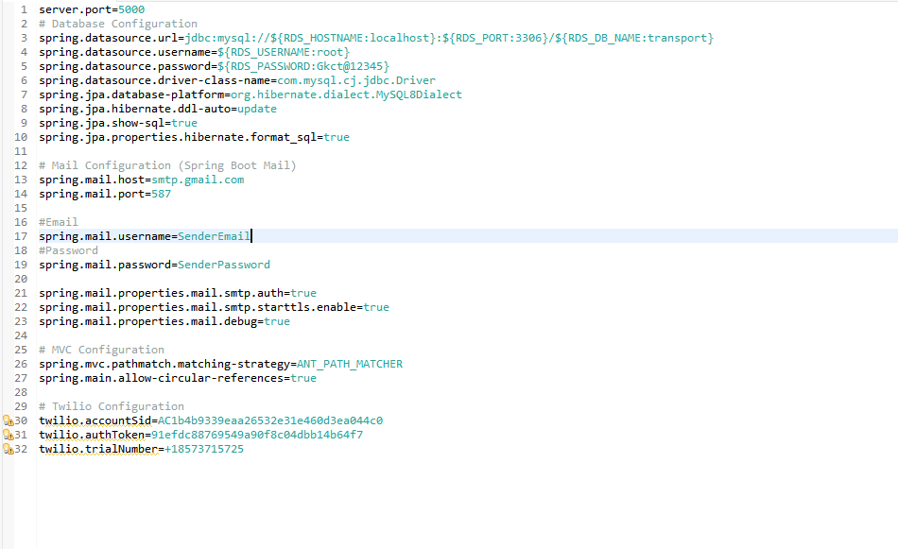

1. **Createing JAR file in STS**
2. **Open STS and Right click on your project (Stop Console if localhost running)**

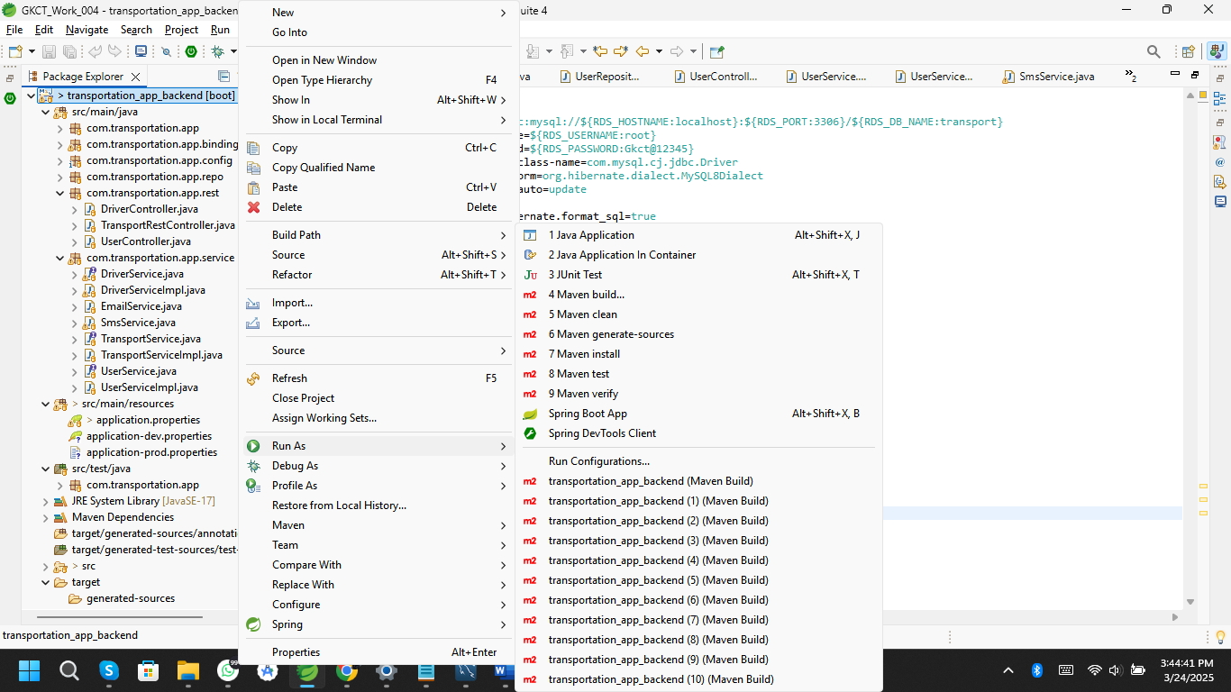

1. **Go to Run As then Maven Clean (wait it will clean Maven)**

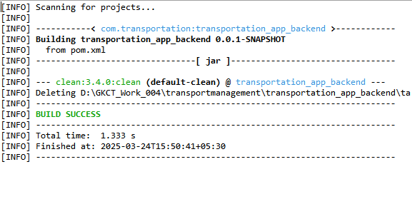

1. **After that Once again Go to Run As and then Maven Build it will open a window their in “Goals” type “ clean package ” then in down Click “RUN”.**

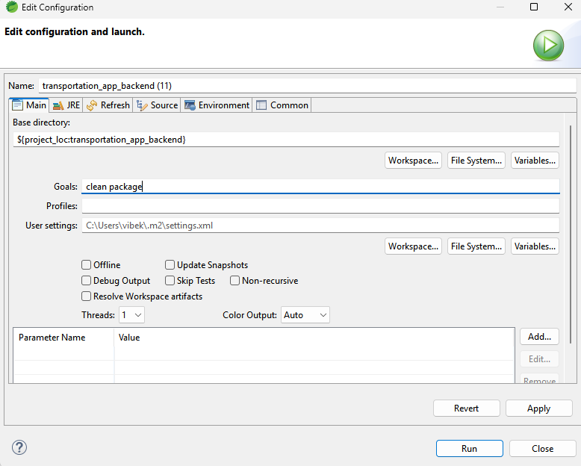

1. **It will generate JAR file .**

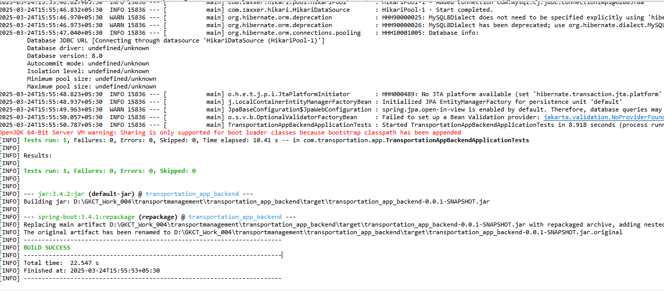

1. **JAR file location is yourProjectfile>target>jarfile**

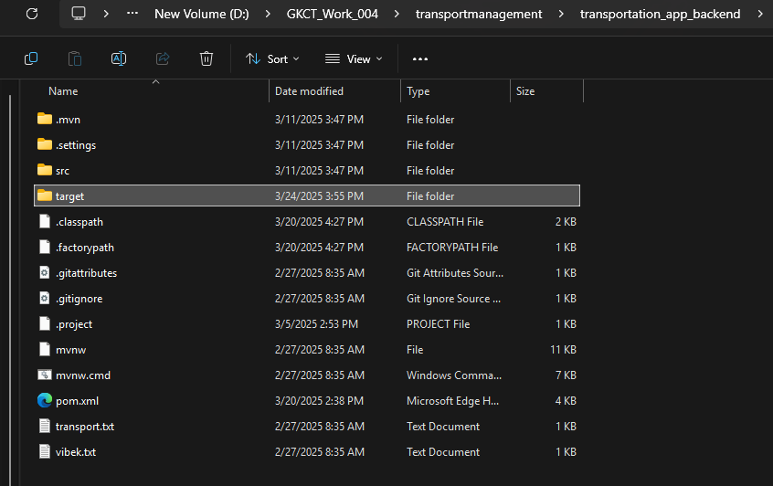

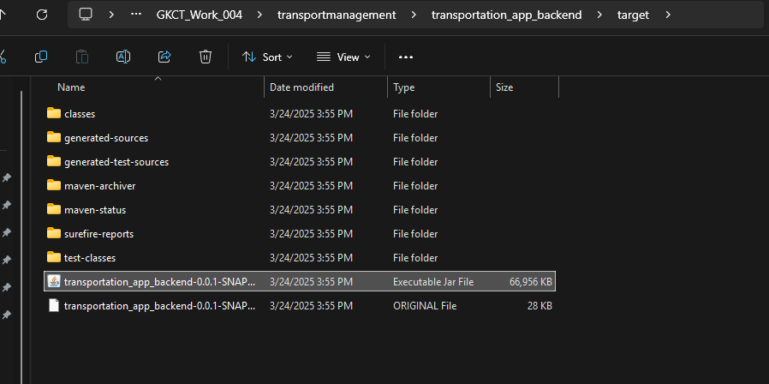

**AWS Environment Creation**

**1.Log in as Root user with AWS ID & Password**

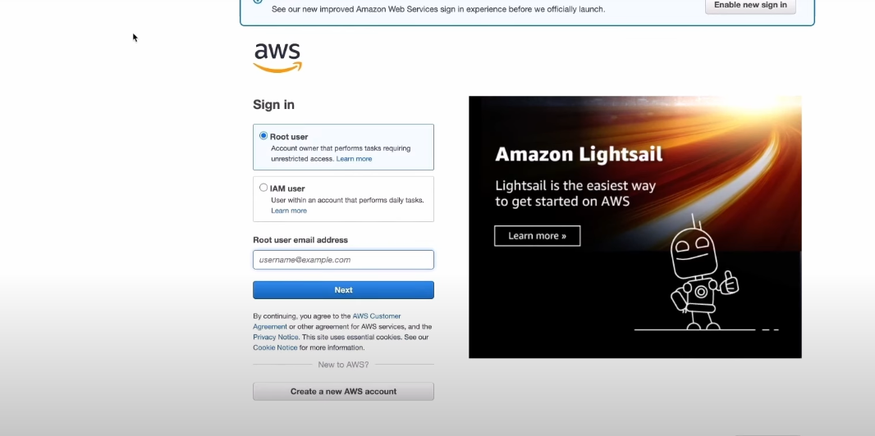

2. Search “ Elastic Beanstack “ on Search bar and click on it.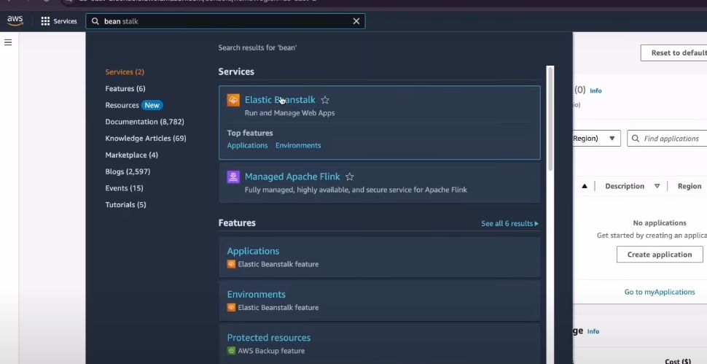

3. click on create application

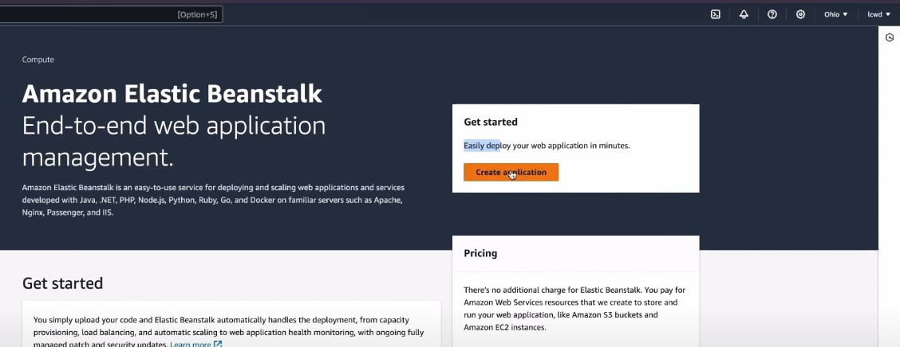

4. click on Web server environment & Give a Application Name.

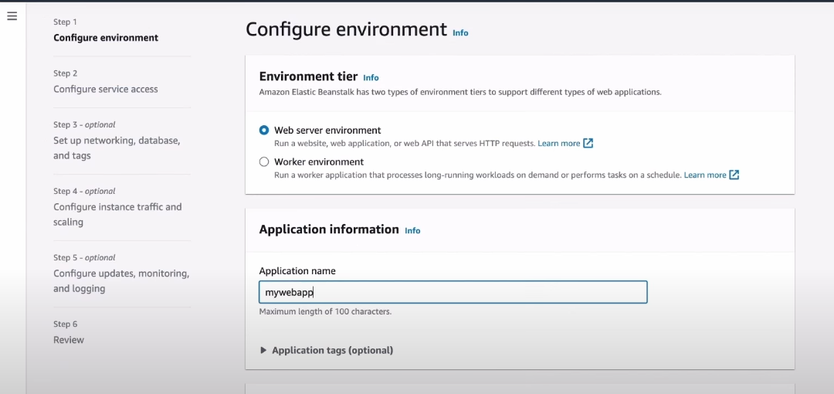

5. type a Domain for application click on check availability

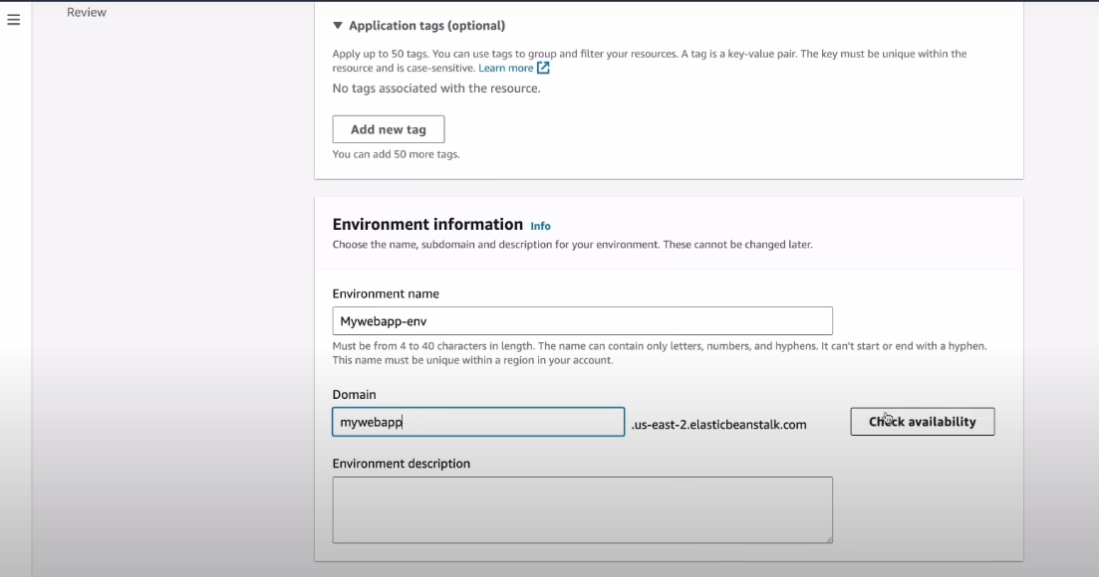

1. In Platform type - Managed Platform, Platform – java, Platform branch – your project java version mine 17, Platform version – automatically chosen.

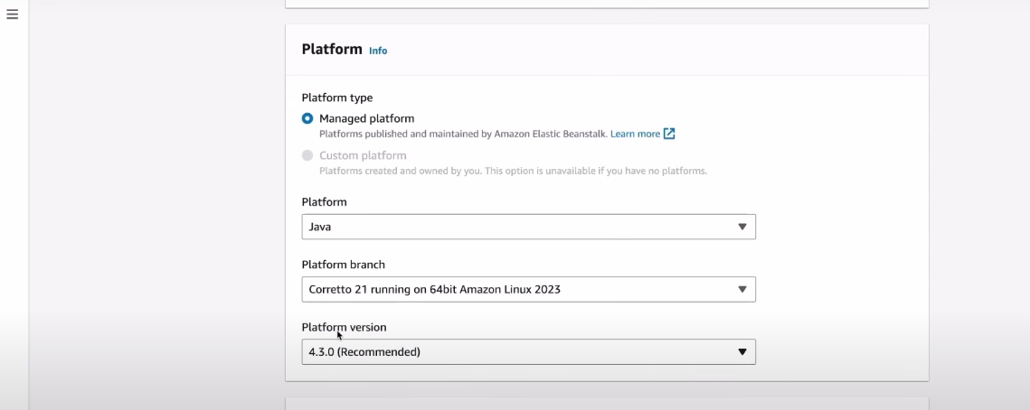

1. Application code - sample application, because we will upload our spring boot project jar file after creating it. And Presents - Single instance (free tire eligible), then click- NEXT.

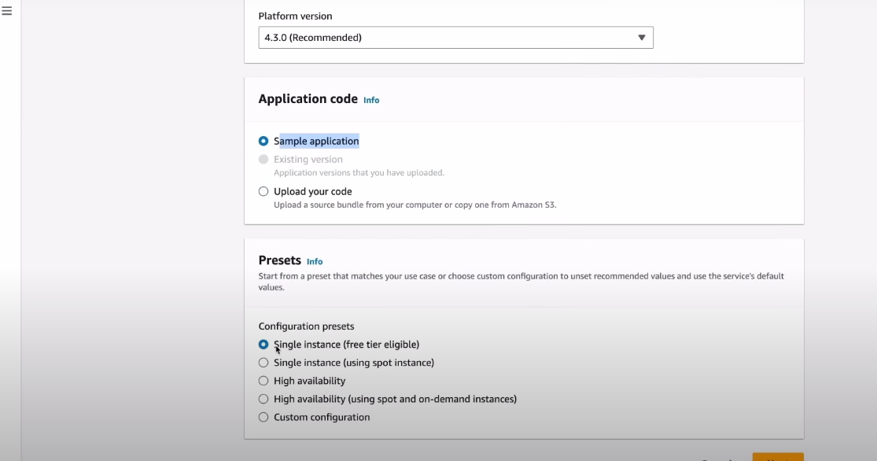

1. Here Select Create and use new service role (first time ) because it will create” aws-elasticbeanstalk-service-role”. if already created before select - Use an existing service role.

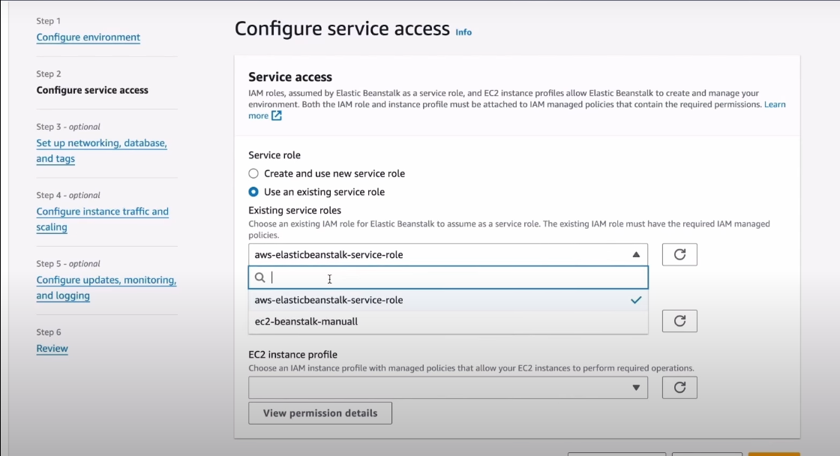

1. In EC2 instance profile for New user it will show No option New user Click on

**View permission details (we have to add 3 permission)**

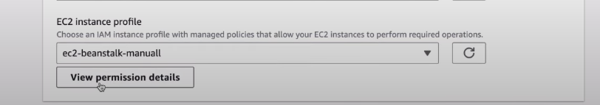

1. Click on **IAM console** for adding the permissions .

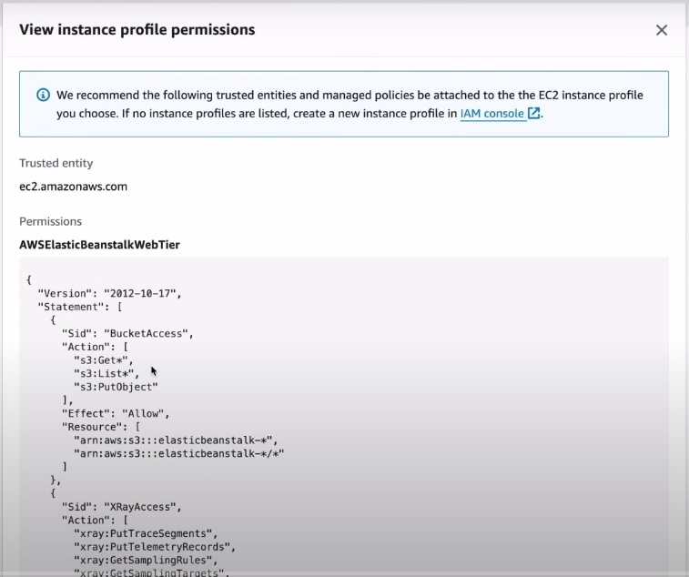

1. Click on Create role

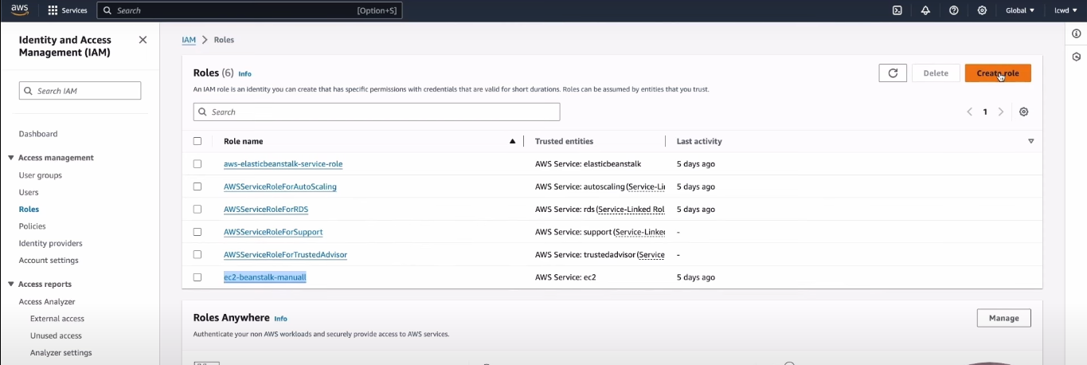

1. Click on AWS service and ,Use case > Service or use case – type EC2 and select it then click NEXT and follow step By step method I mention bellow.

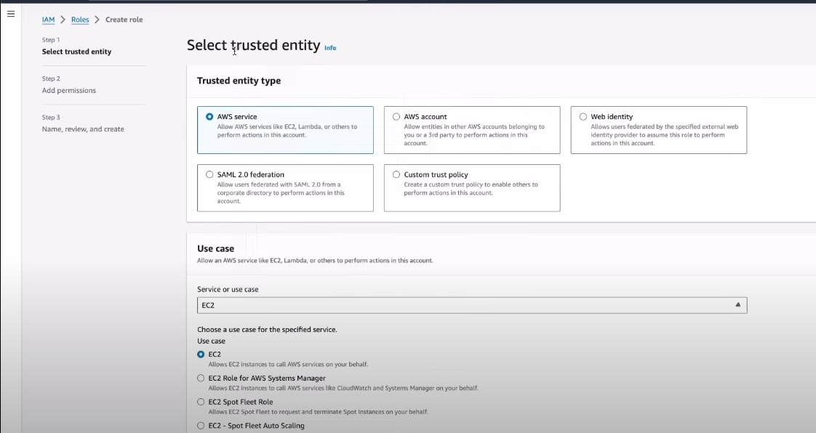

13.in search bar first type ‘ AWSElasticBeanstalkWebTire ’ and select it, do not click on NEXT we have to add 2 more permission in same role.

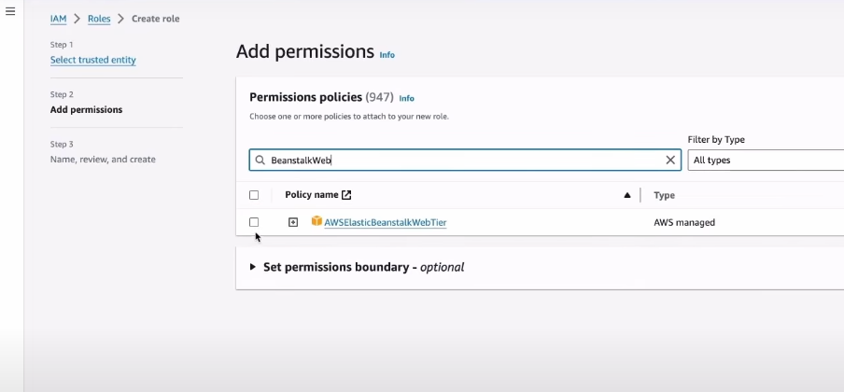

14. Search “ AWSElasticBeanstalkWorkerTier ” and select it.

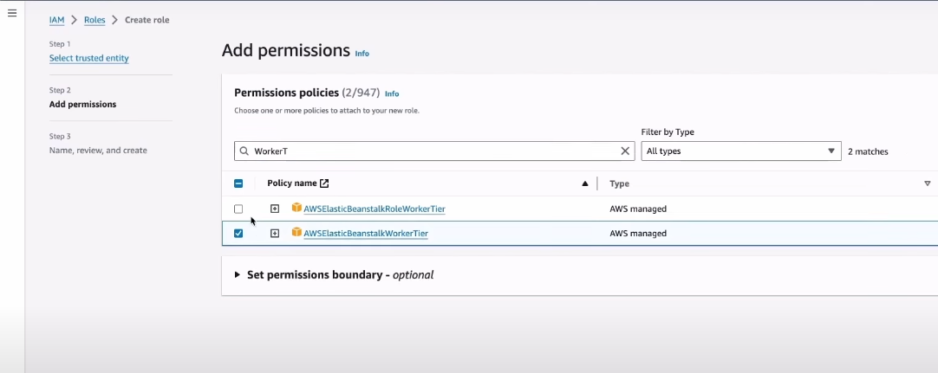

15. search “ AWSElasticBeanstalkMulticontainerDocker ” and select it NOW Click on NEXT .

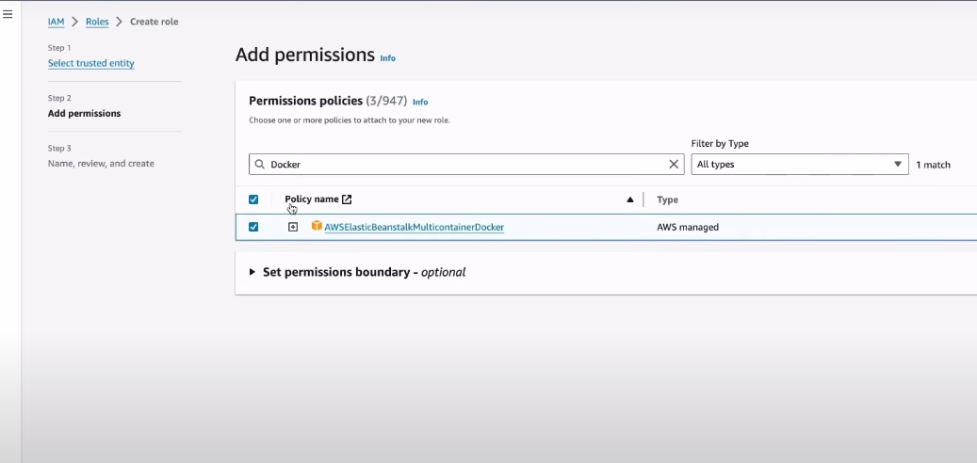

16. give a role name which you like (EX: ec2-beatstalk-manuall) its upon you.

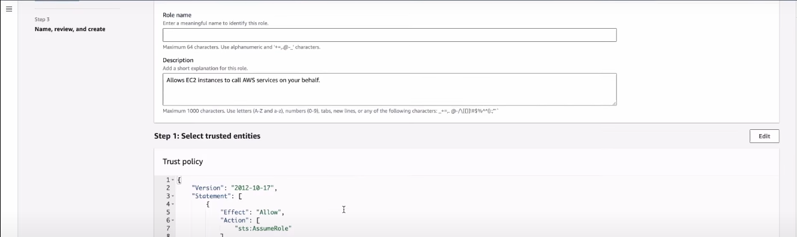

17.Review the options once And Click on Create.

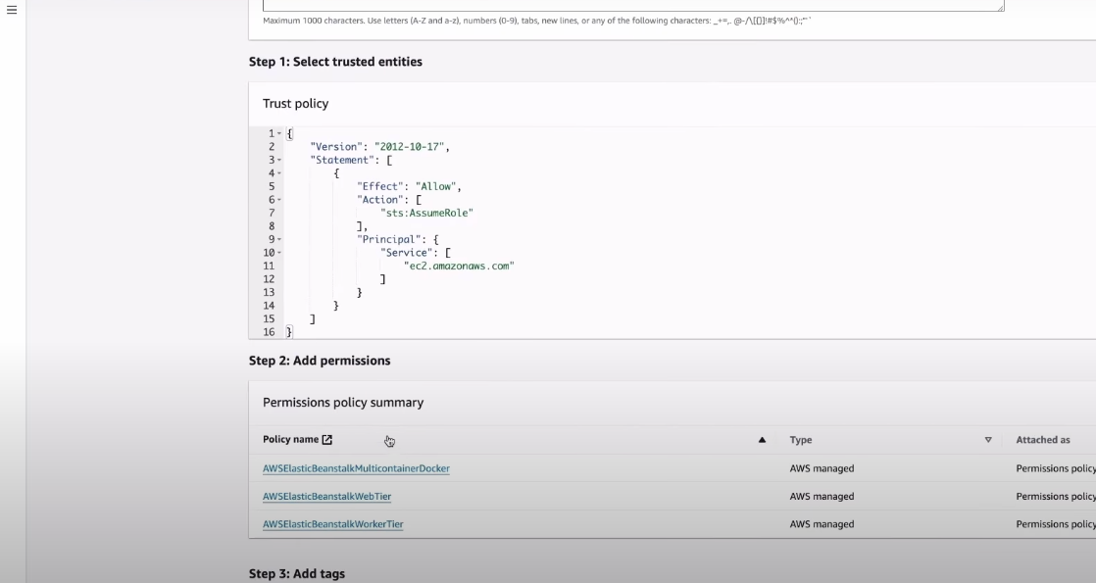

18.Now Go to **EC2 instace profile** select that **ec2-beanstalk-manuall.**

*remember Service role for New USER is **Create and use new Service role**

**Clicek on NEXT.**

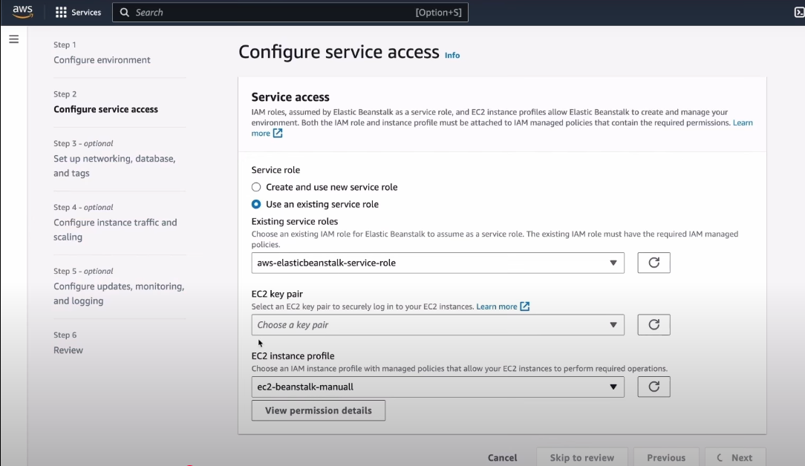

19. Select VPC “ vpc-…… . . . . ” which one available as mention in screenshort

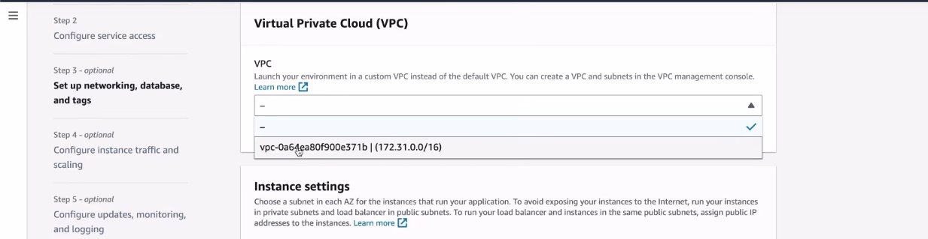

20. Instance subnets select two subnets as mention (it for multiple location accessing this ) also its depend on you .

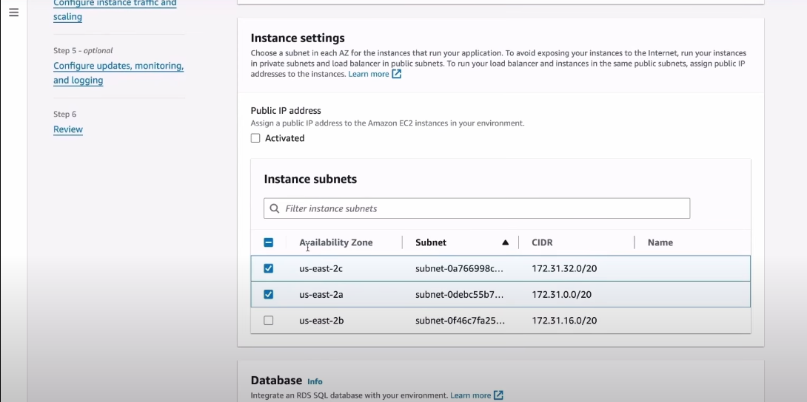

21. Select two subnet for Database also as mentioned bellow.

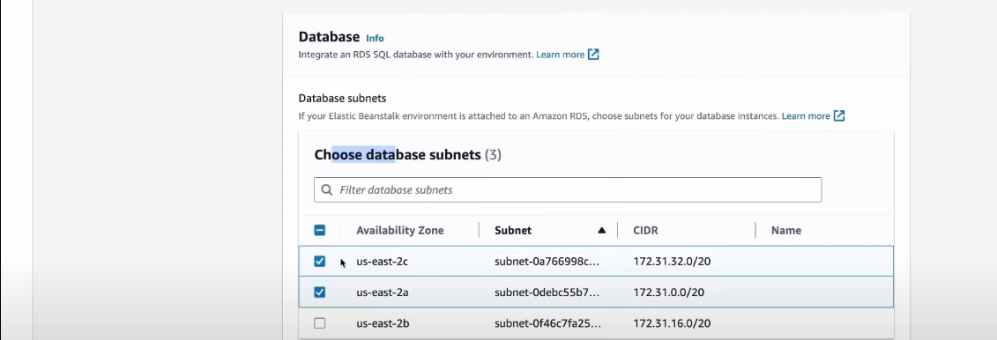

22. Now Click **Enable database** and Select **Engine-MySQL** , **Engine version**-Select as per your mysql version and everything selected by default.

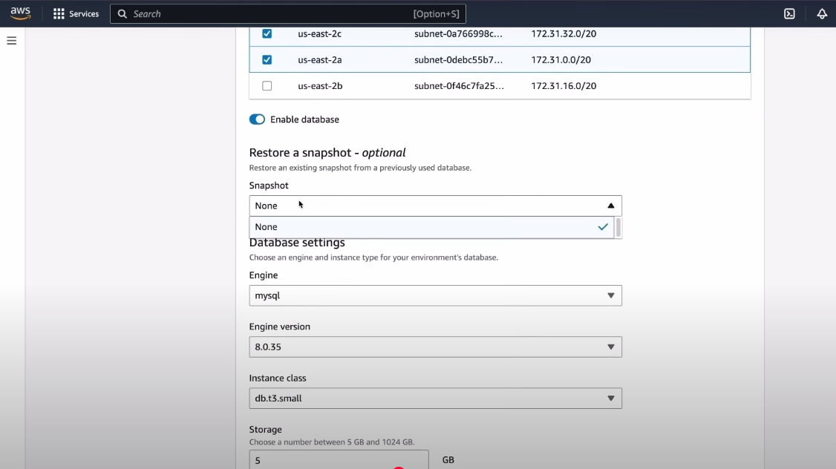

23. Give USERNAME & Password for AWS MySQL DB accessing.(it is not nessary to add same as your local databse if you want different username & password you can).

*Then Database deletion policy select DELETE

CLICK NEXT.

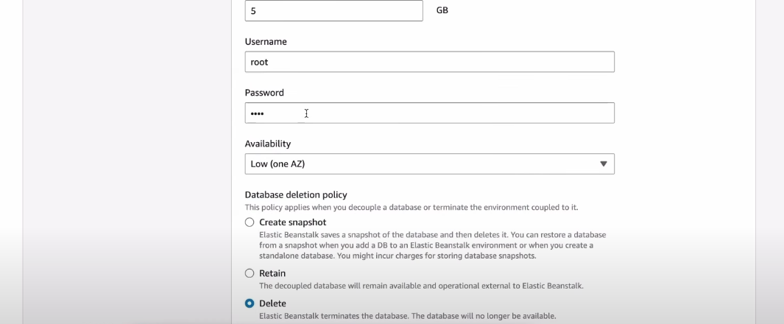

24. follow screenshort as mension.

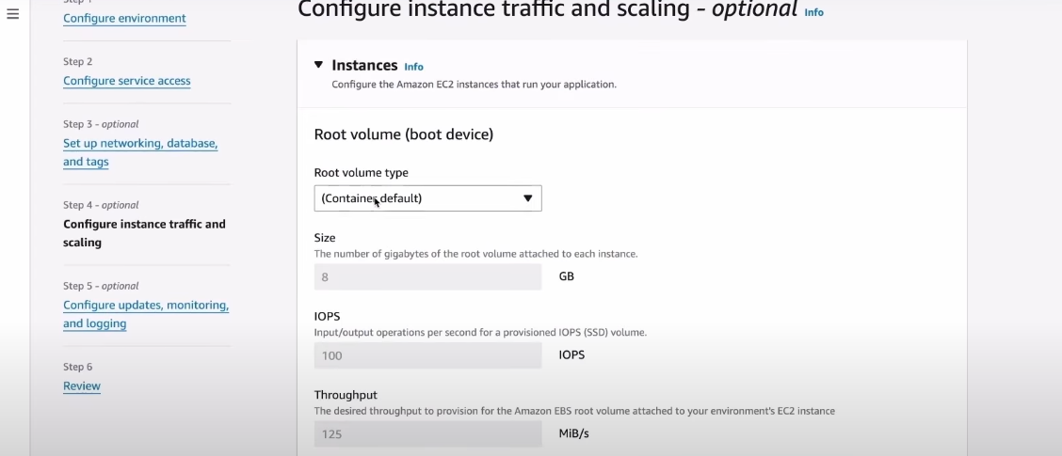

25. EC2 security groups select **default** and rest should be all by default **CLICK ON NEXT**

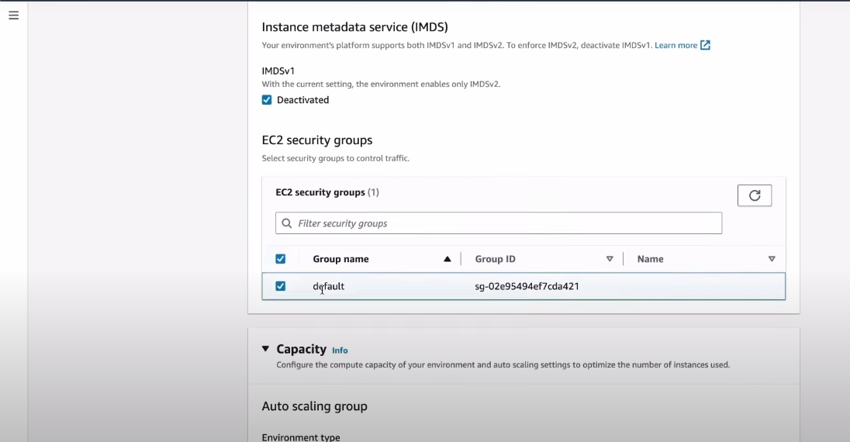

26. In this Page Health reporting Select **Basic.**

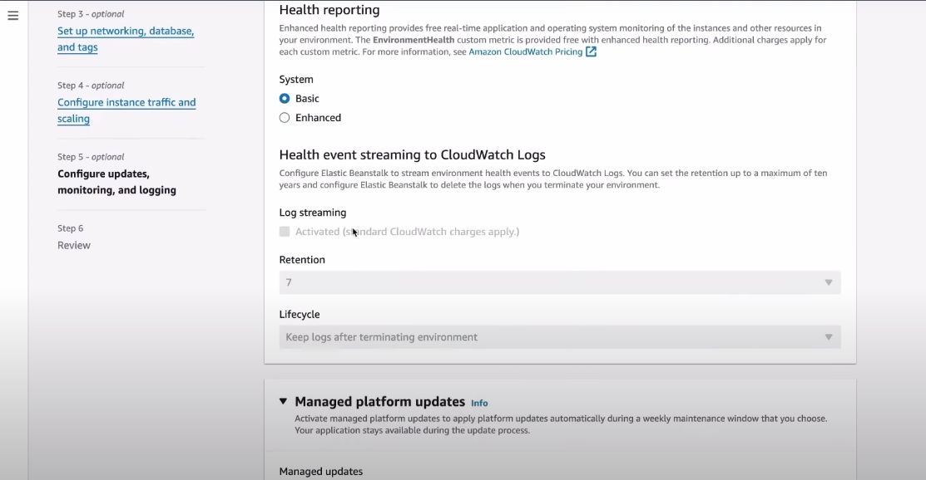

27. In Managed platform updates > Manage updates - [Un-tik] Activated , as I mentioned bellow.

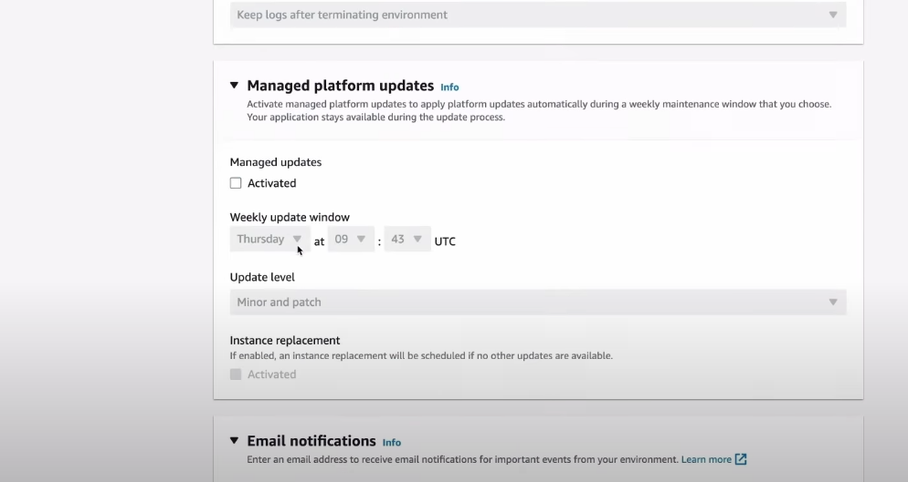

28. > As we changed Before our application.Properties we can now configure our AWS Environment Properties here.

> We have to add Names as mention RDS_username & Password (* which is mention in step 23)

> But a new user can’t have RDS_HOSTNAME , RDS_DB_NAME , RDS_PORT just leave it empty for now we will create after the AWS environment Run. **CLICK ON NEXT it will create ENV**

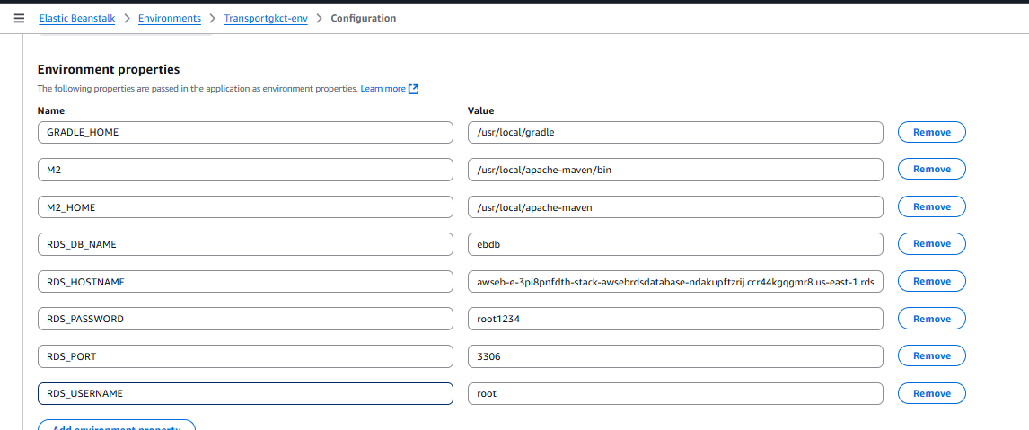

29. Wait for few minutes for Environment overview Health- Unknowen to Green

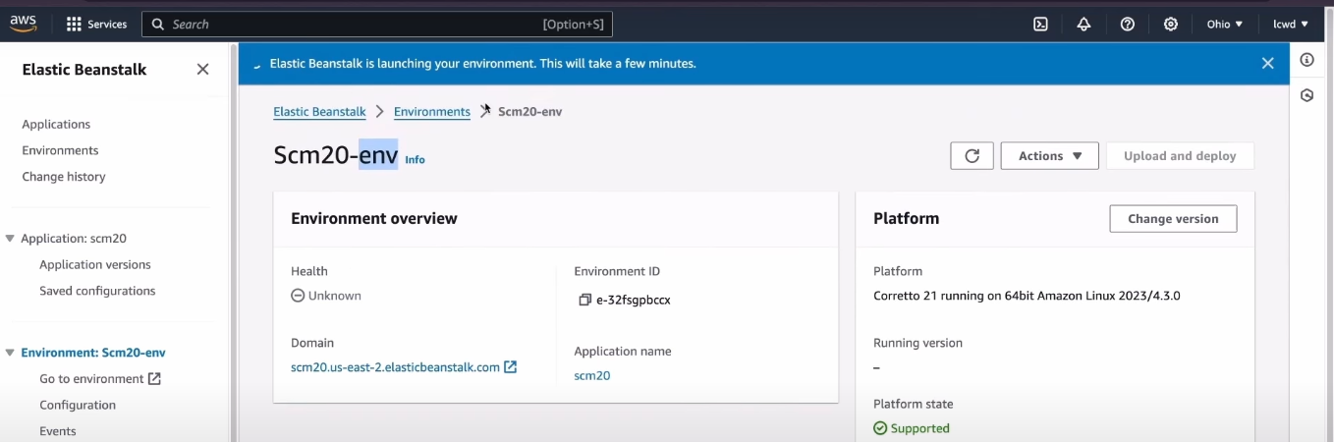

30. After that we want 2 things DB local host and DB name which is in AWS

DB local host and DB name .

1. Search RDS and Click on Aurora and RDS

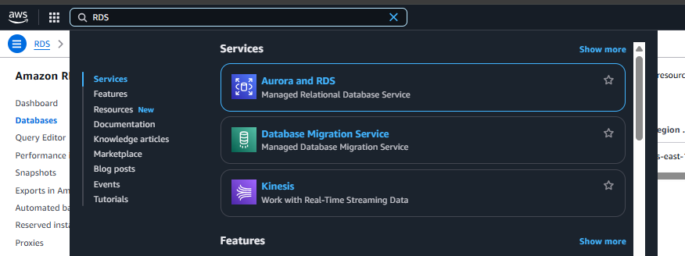

1. Click On DB instances

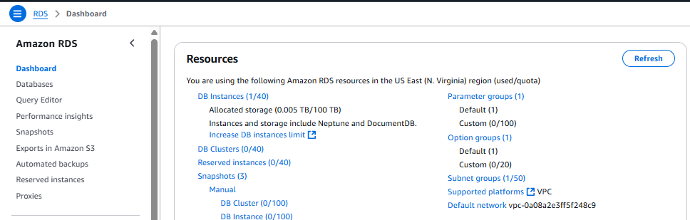

1. **Under Dtabases >> DB identifier >> click awseb-e-……. As mention.**

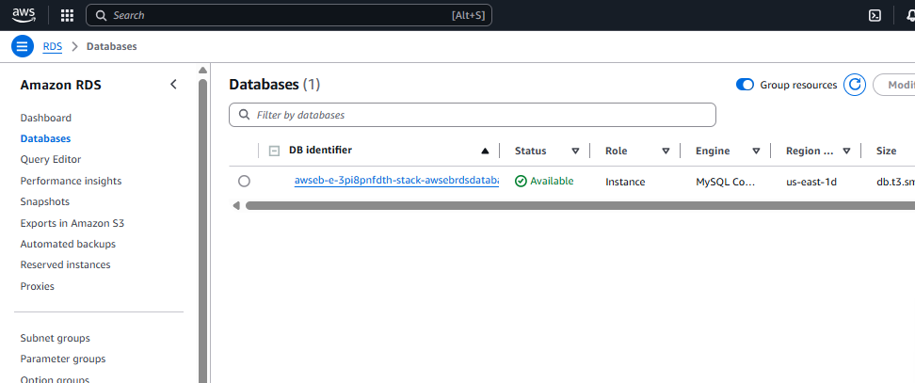

1. Here Copy the Endpoint

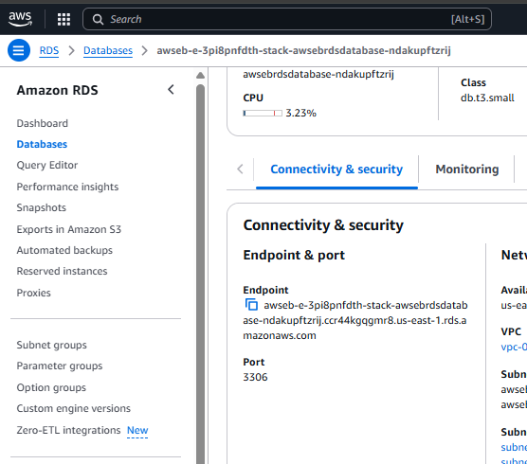

1. **Slide to left you will find Configuration there for DB name**

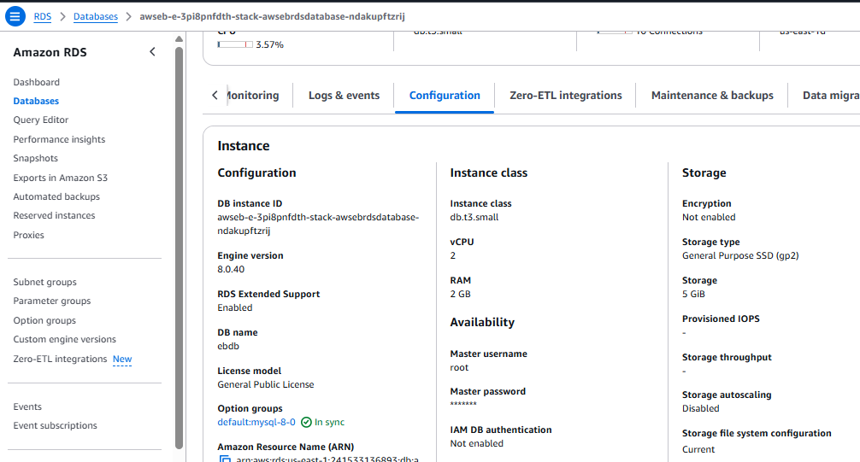

1. **Search ElasticBeanstalk**

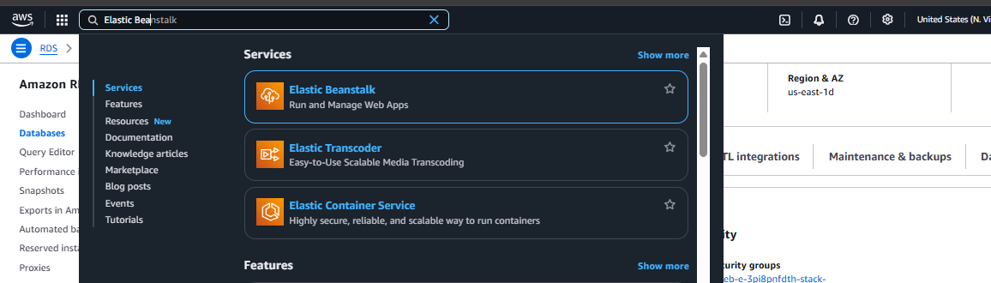

1. Click on Environment (Ex.Transportgkct-env)

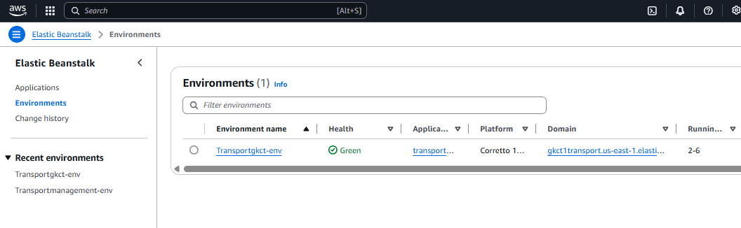

1. Click on Configuration

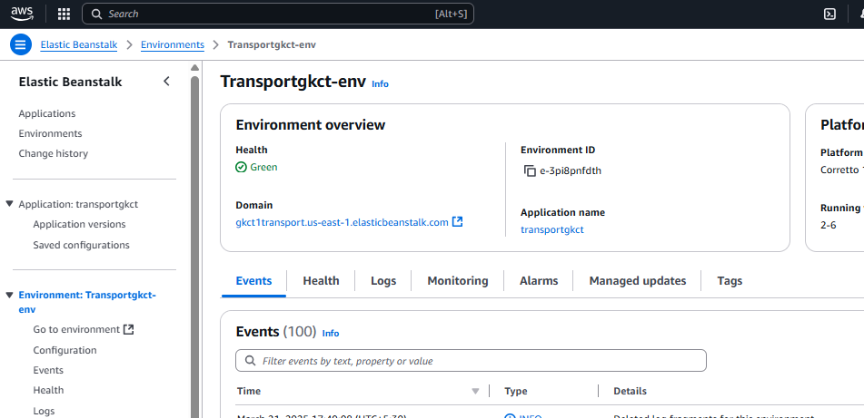



1. In Configuration go to (Update ,monitoring , and logging)’s Edit  
   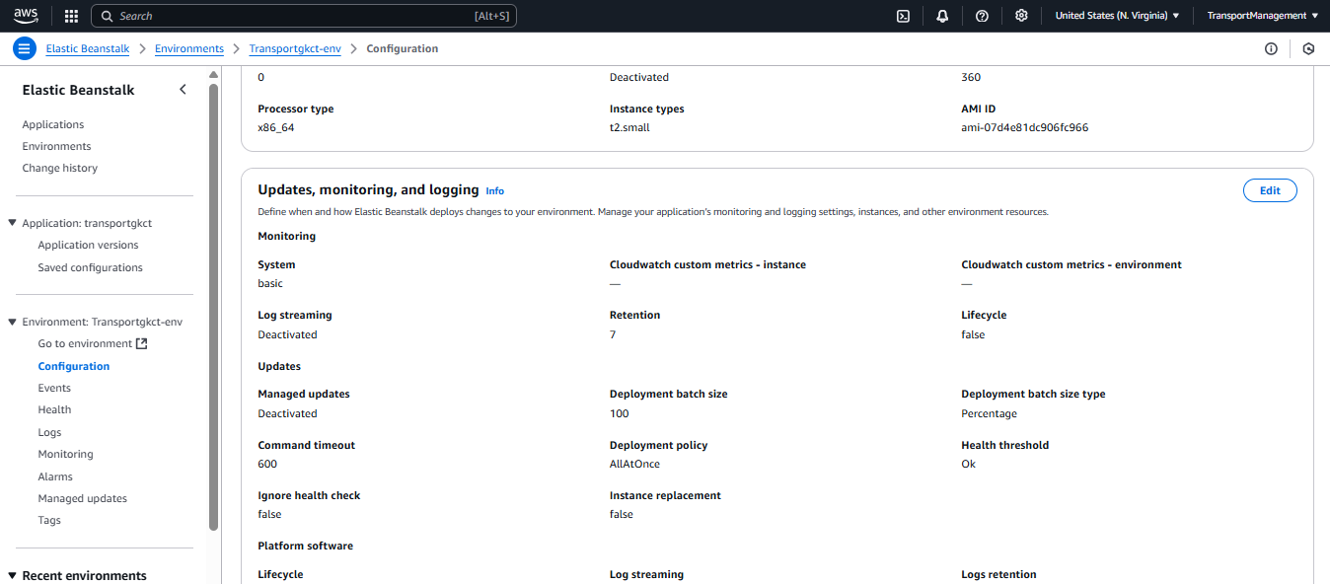



1. Paste that Endpoint in RDS_HostName – Value Section and then apply it.

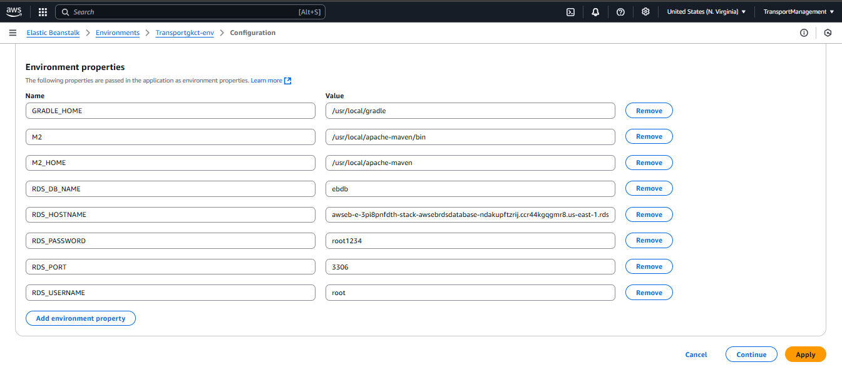

31. Now we have to deploy JAR file for that just Come to Environment in ElasticBeanstalk also you can follow screen short bar for location of the page & CLICK ON **Upload & deploy.**

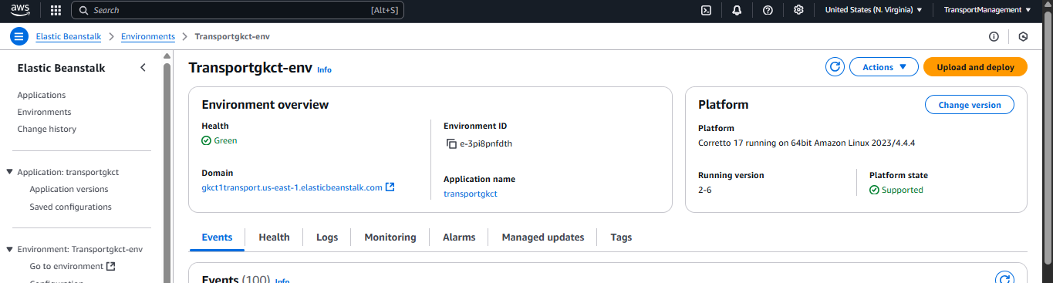

32. Now Click on **Choose files** We have to upload our JAR file which is in projectfile > target >JARfile then give a **Version label-** (EX:1.0) Then click on Deploy.

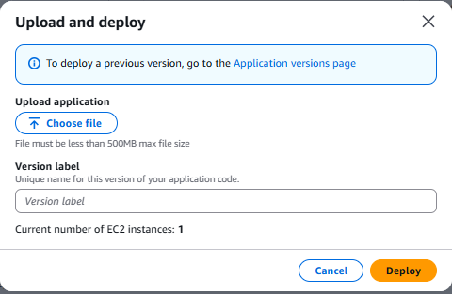

33. it will Start after some time After deployment.

34. for using swagger add “ /swagger-ui/index.html ”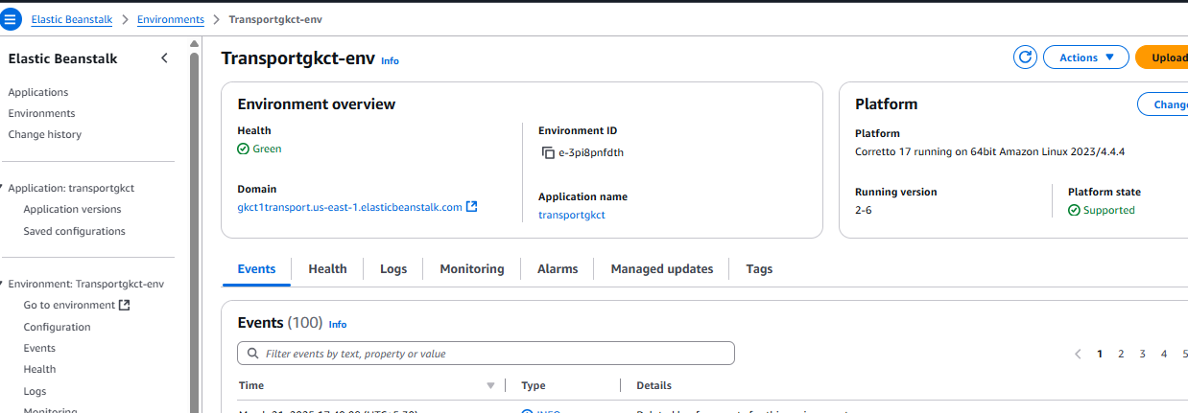

Ex: http://gkct1transport.us-east-1.elasticbeanstalk.com/swagger-ui/index.html